
Spotify Data Analysis – Power BI Project Report
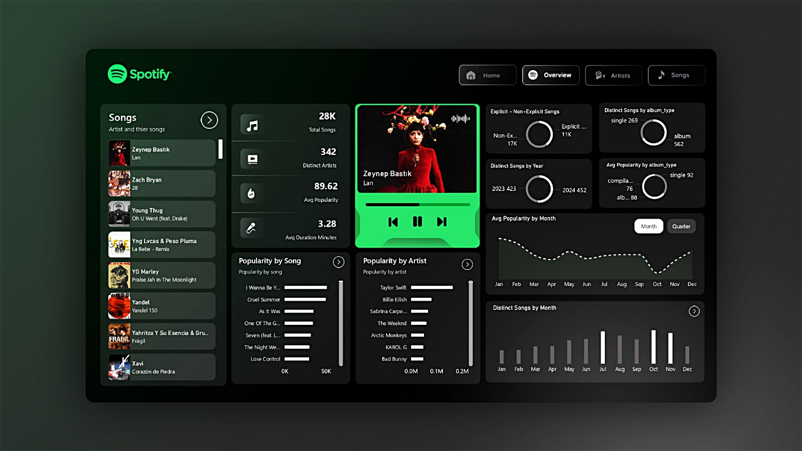
Github Link :
https://github.com/KumarBoste/Spotify_Data_Analysis

1. Project Objective
The objective of this project is to analyze Spotify music data using Power BI to uncover meaningful insights about song performance, artist popularity, and listening trends. The dashboard is designed to provide a comprehensive, interactive view of Spotify data across three key perspectives: Overview, Artists, and Songs. This analysis helps understand content performance, user preferences, and industry trends that can support data-driven decisions in music analytics.

2. Problem Statement
With the exponential growth of digital music platforms like Spotify, understanding which artists and songs drive popularity, how content is released over time, and what factors influence listener engagement has become increasingly complex. Key challenges addressed in this project include:
- Identifying the most popular artists and songs across the platform
- Understanding trends in song releases by year and month
- Analyzing differences between explicit and non-explicit content
- Comparing performance across album types (single, album, compilation)
- Evaluating song duration and popularity patterns
This project aims to solve these challenges by transforming raw Spotify data into clear, actionable insights using interactive Power BI visualizations.

3. Dashboard Sections & Data Visualizations
A. Overview Dashboard
The Overview page provides a high-level summary of Spotify’s music dataset.
Key Visualizations & Metrics:
- Total Songs: 28K+ songs analyzed
- Distinct Artists: 342 unique artists
- Average Popularity: 89.62
- Average Song Duration: 3.28 minutes
- Explicit vs Non-Explicit Songs: Donut chart showing higher presence of non-explicit content
- Distinct Songs by Album Type: Albums dominate over singles and compilations
- Average Popularity by Album Type: Singles show higher average popularity compared to albums
- Distinct Songs by Year (2023–2024): Slight growth in song releases
- Monthly Popularity Trend: Line chart showing fluctuations across months
- Distinct Songs by Month: Bar chart highlighting peak release months
Insights:
- Spotify hosts a vast and diverse music library with strong artist participation
- Singles tend to achieve higher popularity than albums
- Song releases and popularity show seasonal patterns

B. Artists Dashboard
The Artists page focuses on artist-level performance and contributions.
Key Visualizations:
- Popularity by Artist: Bar chart showing top artists such as Taylor Swift, Billie Eilish, and The Weeknd
- Tracks by Artist: Average number of tracks per album
- Songs by Artist: Count of distinct songs per artist
- Artist Table: Includes release date, average popularity, chart position, and average duration
Insights:
- A small group of top artists dominate overall popularity
- Artists with fewer releases can still achieve high popularity
- Consistent releases help maintain long-term visibility on the platform

C. Songs Dashboard
The Songs page provides detailed insights into individual song performance.
Key Visualizations:
- Popularity by Songs: Ranking of most popular songs
- Tracks by Songs: Average track count per album
- Songs by Songs: Frequency of song appearances
- Song-Level Table: Displays popularity, release date, chart position, and duration
Insights:
- Hit songs significantly outperform others in popularity
- Recent releases generally show higher engagement
- Song duration typically ranges between 2–4 minutes, aligning with listener preferences

4. Conclusion
The Spotify Data Analysis Power BI Dashboard successfully transforms complex music data into meaningful insights. The analysis reveals that:
- Popularity is concentrated among top artists and hit songs
- Singles outperform albums in average popularity
- Seasonal and temporal trends influence song releases and engagement
- Short-to-medium length songs dominate listener preferences
This project demonstrates the effective use of Power BI for music analytics, showcasing strong data modeling, visualization, and storytelling skills. It highlights how data-driven insights can support strategic decisions for artists, producers, and streaming platforms.

5. Tools & Technologies Used
- Power BI – Dashboard creation & data visualization
- Spotify Dataset – Music and artist data
- Data Modeling & DAX – Measures and calculated insights

6. Power BI DAX Query :
DEFINE

MEASURE 'Top-50-world'[Total Songs] = COUNTROWS('Top-50-world')
MEASURE 'Top-50-world'[Distinct Songs] = DISTINCTCOUNT('Top-50-world'[song])
MEASURE 'Top-50-world'[Distinct Artists] = DISTINCTCOUNT('Top-50-world'[artist])
MEASURE 'Top-50-world'[Avg Popularity] = AVERAGE('Top-50-world'[popularity])
MEASURE 'Top-50-world'[Max Popularity] = MAX('Top-50-world'[popularity])
MEASURE 'Top-50-world'[Min Popularity] = MIN('Top-50-world'[popularity])

MEASURE 'Top-50-world'[Avg Duration Minutes] = AVERAGE('Top-50-world'[duration_ms]) / 60000
MEASURE 'Top-50-world'[Max Duration Minutes] = MAX('Top-50-world'[duration_ms]) / 60000
MEASURE 'Top-50-world'[Min Duration Minutes] = MIN('Top-50-world'[duration_ms]) / 60000

MEASURE 'Top-50-world'[Explicit Songs] = CALCULATE(COUNTROWS('Top-50-world'), 'Top-50-world'[is_explicit] = TRUE())
MEASURE 'Top-50-world'[Non-Explicit Songs] = CALCULATE(COUNTROWS('Top-50-world'), 'Top-50-world'[is_explicit] = FALSE())
MEASURE 'Top-50-world'[Pct Explicit Songs] = DIVIDE([Explicit Songs], [Total Songs], 0)
MEASURE 'Top-50-world'[Avg Popularity Explicit] = CALCULATE(AVERAGE('Top-50-world'[popularity]), 'Top-50-world'[is_explicit] = TRUE())
MEASURE 'Top-50-world'[Avg Popularity NonExplicit] = CALCULATE(AVERAGE('Top-50-world'[popularity]), 'Top-50-world'[is_explicit] = FALSE())

MEASURE 'Top-50-world'[Avg Position] = AVERAGE('Top-50-world'[position])
MEASURE 'Top-50-world'[Position 1 Songs] = CALCULATE(COUNTROWS('Top-50-world'), 'Top-50-world'[position] = 1)
MEASURE 'Top-50-world'[Position 1 Artists] = CALCULATE(DISTINCTCOUNT('Top-50-world'[artist]), 'Top-50-world'[position] = 1)

MEASURE 'Top-50-world'[Avg Tracks per Album] = AVERAGE('Top-50-world'[total_tracks])
MEASURE 'Top-50-world'[Album Type Count] = DISTINCTCOUNT('Top-50-world'[album_type])
MEASURE 'Top-50-world'[Singles Count] = CALCULATE(COUNTROWS('Top-50-world'), 'Top-50-world'[album_type] = "single")
MEASURE 'Top-50-world'[Albums Count] = CALCULATE(COUNTROWS('Top-50-world'), 'Top-50-world'[album_type] = "album")

-- Artist-scoped (use when Artist in context)
MEASURE 'Top-50-world'[Songs per Artist] = COUNTROWS('Top-50-world')
MEASURE 'Top-50-world'[Distinct Songs per Artist] = DISTINCTCOUNT('Top-50-world'[song])
MEASURE 'Top-50-world'[Avg Popularity per Artist] = AVERAGE('Top-50-world'[popularity])
MEASURE 'Top-50-world'[Position1 Hits per Artist] = CALCULATE(COUNTROWS('Top-50-world'), 'Top-50-world'[position] = 1)

-- Time-scoped (use when Year in context)
MEASURE 'Top-50-world'[Songs per Year] = COUNTROWS('Top-50-world')
MEASURE 'Top-50-world'[Avg Popularity per Year] = AVERAGE('Top-50-world'[popularity])
MEASURE 'Top-50-world'[Avg Duration per Year] = AVERAGE('Top-50-world'[duration_ms]) / 60000
MEASURE 'Top-50-world'[Pct Explicit per Year] = DIVIDE(
CALCULATE(COUNTROWS('Top-50-world'), 'Top-50-world'[is_explicit] = TRUE()),
[Songs per Year],
0
)

EVALUATE

SUMMARIZECOLUMNS(
"Total Songs", [Total Songs],
"Distinct Songs", [Distinct Songs],
"Distinct Artists", [Distinct Artists],
"Avg Popularity", [Avg Popularity],
"Max Popularity", [Max Popularity],
"Min Popularity", [Min Popularity],
"Avg Duration Minutes", [Avg Duration Minutes],
"Max Duration Minutes", [Max Duration Minutes],
"Min Duration Minutes", [Min Duration Minutes],
"Explicit Songs", [Explicit Songs],
"Non-Explicit Songs", [Non-Explicit Songs],
"Pct Explicit Songs", [Pct Explicit Songs],
"Avg Popularity Explicit", [Avg Popularity Explicit],
"Avg Popularity NonExplicit", [Avg Popularity NonExplicit],
"Avg Position", [Avg Position],
"Position 1 Songs", [Position 1 Songs],
"Position 1 Artists", [Position 1 Artists],
"Avg Tracks per Album", [Avg Tracks per Album],
"Album Type Count", [Album Type Count],
"Singles Count", [Singles Count],
"Albums Count", [Albums Count],
"Songs per Artist", [Songs per Artist],
"Distinct Songs per Artist", [Distinct Songs per Artist],
"Avg Popularity per Artist", [Avg Popularity per Artist],
"Position1 Hits per Artist", [Position1 Hits per Artist],
"Songs per Year", [Songs per Year],
"Avg Popularity per Year", [Avg Popularity per Year],
"Avg Duration per Year", [Avg Duration per Year],
"Pct Explicit per Year", [Pct Explicit per Year]
)

